-THE IF WORKS JUST LIKE IN C

- === is used to check for value and type

-truthy and falsy is the shorter way to check values 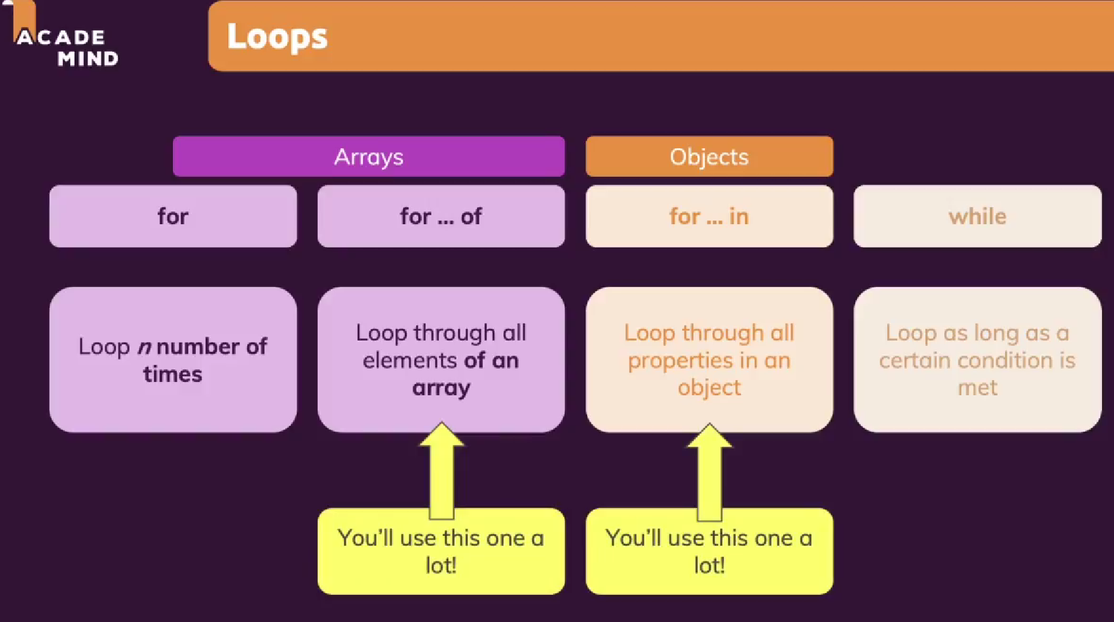

-The for off works with arrays

-in the 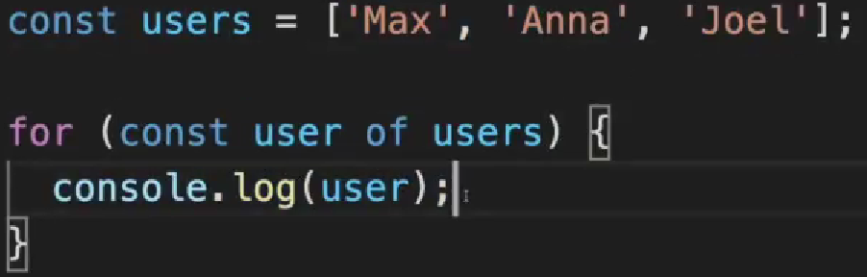

-for in is used for objects

-This is used to access the objects

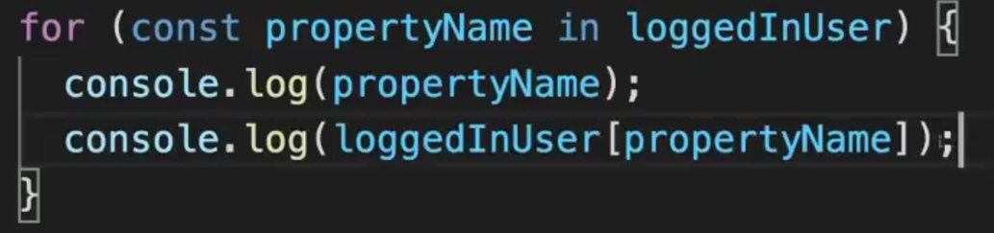

-This is used to access values

-confirm is kinda like alert but with built in yes and no button

-math.random is used to make it random